Exp-6
Digital Clock
Code:
<!DOCTYPE html>
<html>
<head>
<title>Digital Clock</title>
</head>
<body>
<h1>Digital Clock!</h1>
<h2 id="time"></h2>

<script>
function display() {
var d = new Date();
var h = d.getHours();
var m = d.getMinutes();
var s = d.getSeconds();

document.getElementById("time").innerHTML =
h + ":" + m + ":" + s;
}

display();
setInterval(display, 1000);
</script>
</body>
</html>

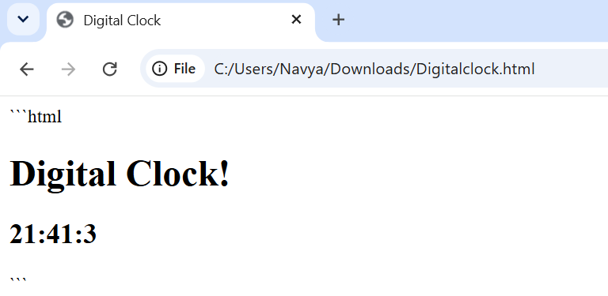
Dynamic Background Colour
Code:
<!DOCTYPE html>
<html>
<head>
<title>Dynamic Background</title>
</head>
<body>
<h1>Dynamic Background!</h1>

<script>
function setBackgroundColor() {
var red = Math.floor(Math.random() * 256);
var green = Math.floor(Math.random() * 256);
var blue = Math.floor(Math.random() * 256);

var color = "rgb(" + red + "," +
green + "," + blue + ")";

document.body.style.backgroundColor = color;
}

setBackgroundColor();
setInterval(setBackgroundColor, 30000);
</script>
</body>
</html>
Output:
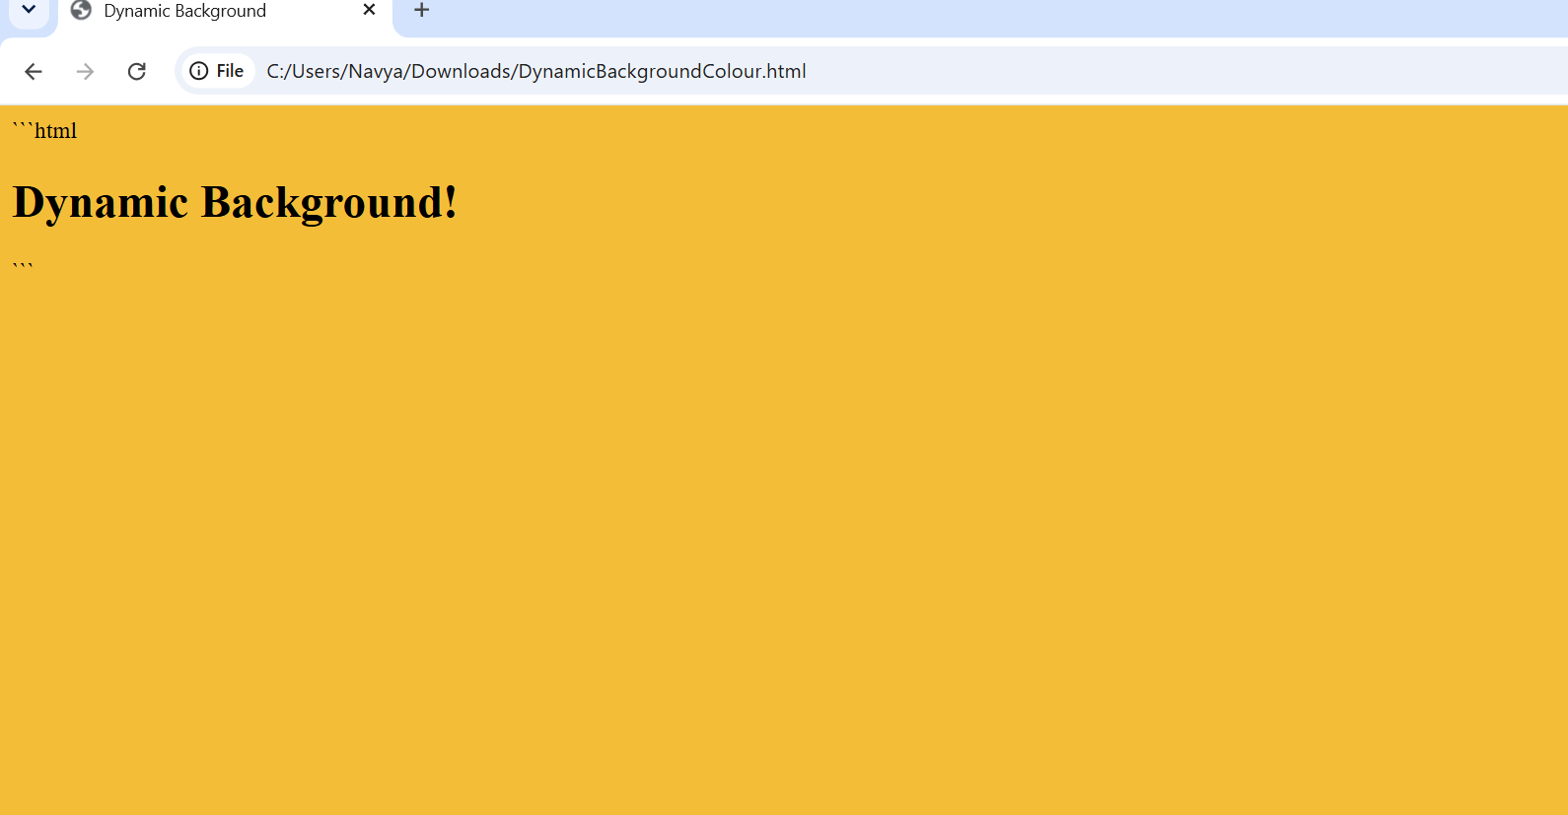
After 30 sec

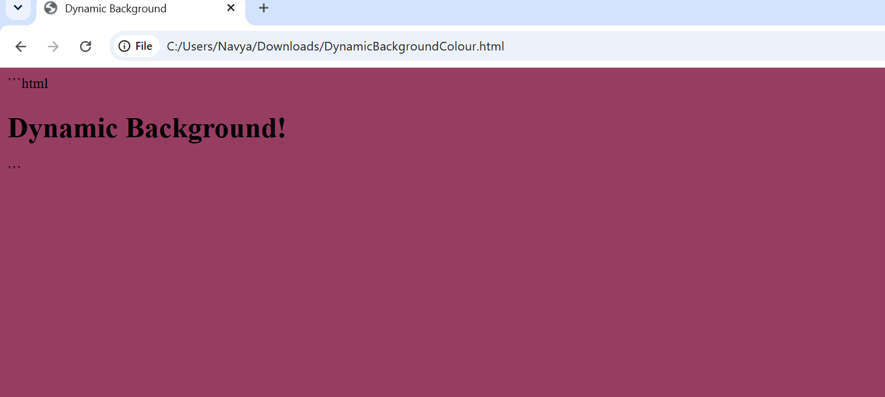
Change Font Size Using Mouse Events
Code:
<!DOCTYPE html>
<html>
<head>
<title>Change Font Size</title>
</head>
<body>
<h1>Change font size!</h1>

<p id="para1"
onmouseover="incSize()"
onmouseout="decSize()">
Move cursor over me to zoom in...
</p>
<script>
function incSize() {
document.getElementById("para1")
.style.fontSize = "28px" }
function decSize() {
document.getElementById("para1")
.style.fontSize = "16px"; }
</script>
</body>
</html>
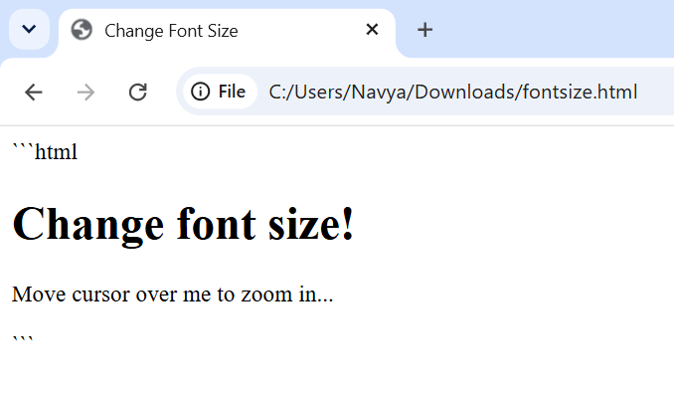
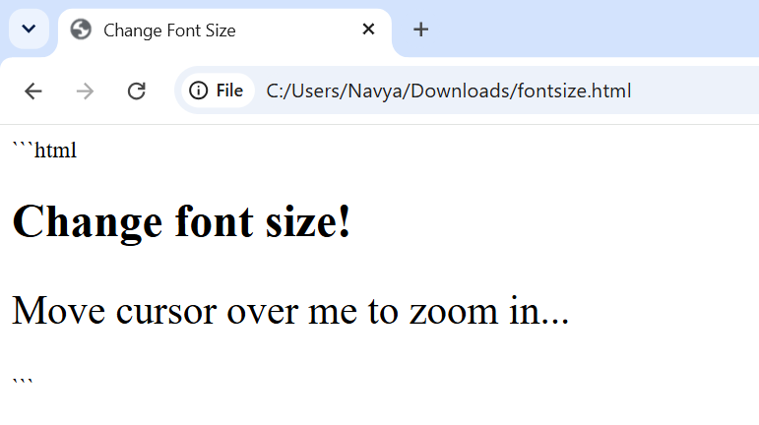
Move and Stop a Car Image
Code:
<!DOCTYPE html>
<html>
<head>
<title>Move Car</title>
</head>
<body onload="init()">
<h1>Move the Car</h1>

<img id="img"
src="https://placehold.co/100x50?text=CAR"
style="width:100px; position:relative; left:0px;">

<br><br>
<button onclick="moveRight()">Move</button>
<button onclick="stop()">Stop</button>

<script>
var imgObj;
var animate;

function init() {
imgObj = document.getElementById("img");
imgObj.style.position = "relative";
imgObj.style.left = "0px";
}

function moveRight() {
imgObj.style.left =
parseInt(imgObj.style.left) + 1 + "px";

animate = setTimeout(moveRight, 10);
}

function stop() {
clearTimeout(animate);
}
</script>
</body>
</html>
Output:
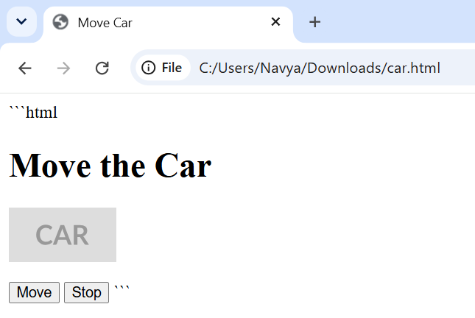
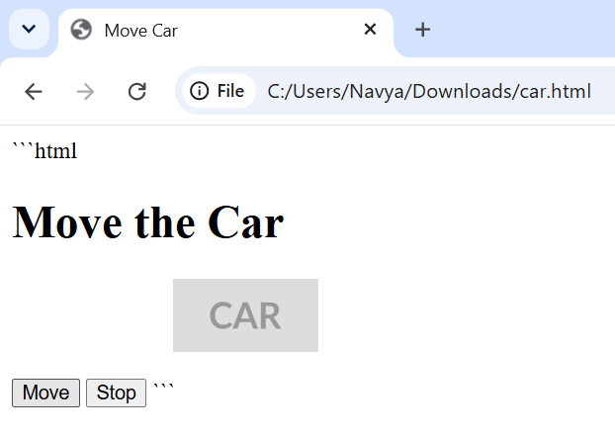
Array of Student Objects
Code:
<!DOCTYPE html>
<html>
<head>
<title>Student Details</title>
</head>
<body>
<h1>Student Details</h1>
<div id="demo"></div>

<script>
var student = [
{ name: "John", r_num: "123", dob: "20-apr-1995" },
{ name: "Joseph", r_num: "456", dob: "05-jan-1998" },
{ name: "David", r_num: "789", dob: "10-jun-2002" }
];

var output = "";

for (var i = 0; i < student.length; i++) {
output += student[i].name +
"'s Register Number is " +
student[i].r_num + "<br>";

var year = parseInt(student[i].dob.slice(-4));

if (year < 2000) {
output += "Born before 2000<br>";
} else {
output += "Born in 2000 or after<br>";
}

output += "<br>";
}

document.getElementById("demo").innerHTML = output;
</script>
</body>
</html>
Output:


